Order No: 23 of 2025
Dated: 18-06-2025

Subject: Constitution of Committee for PM Vishwakarma, PMKVY 4.0, and PMIS (PM Internship Scheme) & Mission YUVA.

For the effective implementation of PM Vishwakarma, PMKVY 4.0,PMIS and Mission YUVA, a committee of officers/officials is hereby constituted:

1. Mr. Mudasir Rashid, Lecturer-I, Automobile Engineering
Role: Chairperson
2. Mr. Mohd Amin Wani, Lecturer-I, Electrical Engineering
3. Mr. Raies Ahmad Khan, Demonstrator, Mechanical Engineering
4. Mr. Wajahat, Demonstrator, E&C Engineering
The committee will submit the status of these schemes to the office of the undersigned on a fortnightly basis and as and when required.

No: KGP/Estt/2025/397
Dated:18-06-2025
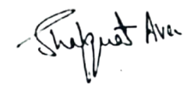

Dr. Shafquat Ara
Principal
Kashmir Govt.Polytechnic College Srinagar

Copy to:
1. All committee members for compliance.

